**Online Catering Reservation System**

An Undergraduate Capstone Project Proposal

Presented to the

Panel of Examiners

Cebu Technological University

TABOGON EXTENSION

Poblacion, Tabogon, Cebu

In Partial Fulfillment

Of the Requirements for the Degree

BACHELOR OF SCIENCE IN INFORMATION TECHNOLOGY

Callao, Jevy

Nuena, Joper G.

Quimque, Darwin M.

Quinain, Juramie

Sabturani, Ghruham

Saladaga, Carlo D.

Saladaga, Edrian

Tuling, Dindo

**Chapter I**

**THE PROBLEM AND ITS SCOPE**

**INTRODUCTION**

**Project Context**

Nowadays, major marketing strategies aimed through INTERNET. Most business enterprises seek to offer their services through online. Thus, the researcher of the system entitled Online Catering Reservation proposed a system that offers services that is style, portable, accessible and easy to use. Since, internet is available everywhere it easy for the users to book a reservation even they’re far from the location. This system gives much advantage for those busy person because they only have to check then book a reservation on their cellular phone with internet without hassle. This system will be a friendly user so that everyone will be applicable to use it. With the help with this system the user can now automatically book reservations as well as they have the ability to check the availability quickly. User will love this system for it will not make delay and it easy also to cancel if there is hesitation. In addition, they can also avoid traffics, cost on travelling for they can no longer go to the exact location to book a reservation. In this proposed system the researchers made some improvement than the traditional way on reserving a catering. In traditional system, requires much time and usually causes delays, problems and hassle.

The proposed system can provide efficient facilities to both management/admin and to the users in fulfilling their needs. The user can view some details related in catering services and they can also reserve a service on which time and date. In addition, the management can retrieve and view all the reservation on that particular day and will determine the number of customers for them to identify how many to be catered.

**Purpose and Description of the Project**

The main objective of this project is to develop a web application which supports all aspects of the delivery process through online. This system is a web application which display food menu information and allow customers to place their orders online for delivering. This system not only improves customer’s experience but also eases the workload on the staff. All Customer details, products, operators, order details and sales orders can be stored in the Online Catering Reservation System website.

**General Objectives**

The main objective of this project was to design an Online Catering Reservation System that will lessen the human effort between the Catering Staff and the Customers/ Users.

**Specific objectives**

* To improve the traditional way system to a system that does not requires much time and effort.
* To develop a system that would cater all the customer/users wants, needs in a catering service.
* To create a system that would make the customers satisfactions high as always.
* To provide an error free and hassle-free reservation for customers.
* To provide a system that will help management a confused free job, because everything has been recorded and everything are organized.
* To provide a system that will help management a confused free job, because everything has been recorded and everything are organized.

**Scope and Delimitation**

**Scope**

* To reduce on data redundancy such that clients’ data about loans is not lost.
* To minimize on costs by providing effective and efficient system.
* To generate retrieval of clients’ records concerning the loans taken in Pride microfinance.
* To give authority to the administrators to make changes on the look of the system and also manage data online.
* To ease access of data to the administrator since the system is online and can be accessed anywhere in the world.
* To lead to an award of a Bachelor’s Degree of Deformation Technology at Kampala International University.

**Delimitation**

This proposed Online Catering Reservation System does not accept online payment.

**Significance of the Study**

Both the management and the customer will benefit from this system:

**Management/Admin**

This system will help their services grow for it will make the customers satisfaction good. This will also help them enhance their decision making, ordering and reserving process and stock managing. Since this is an online service, so it is easy for them to take the reservation and also easy for them to know if there’s an available or none.

**Customer/user**

It reduces the customers time and cost in travelling. Everything they need could be in just one location online; they can no longer visit in a catering area to reserve. They can book a reservation even they’re at home.

**Chapter 2**

An ordering system is referred to as a set of detail methods that is being used in handling the ordering process. Online Catering Reservation System can be computerized or done manually. Thus helps the customer to order their food themselves which is known as the customer self-ordering system.

The customer self-ordering system can be defined as a computerized system that is being used by customers to place their own orders in the restaurant and allow the orders to be tracked, in order to prepare and deliver the food to the computers.

**Related Systems**

**SELF-SERVICE/SELF-ORDERING IN CATERING ESTABLISHMENTS**

Self-service or self-ordering in restaurant industry refers to the restaurant taking orders from customers through applying various types of technologies such as internet and many others. Self-service or self-ordering is successful when it is applied at restaurants in many other countries. The usage of the self-service or self-ordering technology is proven to benefit most of the investors.

Odesser-Torpey(Odesser-Torpey, 2008) reports that most of the Americans hate waiting for an order. Therefore, they prefer self-service technology, which can be in form of text messaging, the internet and kiosk. Usually, the customer prefers self-service because of speed and convenience in making order and transaction while minimize the miscommunication. He also mentioned that self-activated terminals are more likely to serve as ordering innovation in the future. The implementation of alternative ordering can increase check size, free up counter staff that need to serve customers and take money handling out of service equation.

Bhatnagar(Bhatnagar, 2006) mentioned that the innovation of kiosk and computerized table top ordering screen will force restaurant industry re-jigger an often used acronym quick service restaurant to the self-service restaurant. Customers can get information or search for recipes from the kiosk and internet. The kiosk and internet also takes orders and receives credit cards or debit cards payment. As a result, wrong order and long queue can be avoided, order staff can be arranged to somewhere else and focus to speed up on delivery orders. On the other hand, a table-top touch screen order system can take customer orders as well as handle other customer requests such as refill drinks, call a waiter and make payment by credit card and debit card.

Bytes, a restaurant located at Canterbury has been successfully standing apart from the competitors because of applying online self-service ordering and the payment concepts. The system used in Bytes allows the customers make an order through the touch screen, and the order will be directed to bar or kitchen. The system also offers games after a customer placed the orders while internet access will be provided to customers in the future. Touch screen ordering reduces the need of the waiter. The system also provides database for customers’ habits and preferences, generate the management reports, perform analysis as well as allows the menu to be updated instantly. (Bricker’s, 2006).

Based on study, it is possible for applying the online food ordering system to the fast-food restaurants in Nigeria. This is because the system can improve workplace efficiency, increase sales of the restaurant as well as reduce making incorrect order. As a result, it is worth for investing on the system, whereby it can shorten the return on investment.

In addition, the system should be supported by the food origin taste and services to maintain the customers’ loyalty and satisfaction. However, widely implementing the food ordering system may cause the influx of labor due to the elimination of waiters in restaurant industry. Even the system is important to be implemented, yet there is still some risk in other factors such as a direct interaction and restaurant design concept, which need to be considered for ensuring the success of the system.

Gan(Gan, 2002) proposed to develop an online fast food restaurant ordering system that allows customers to place orders anytime at any place. The system helps to manage order from customer as well as advertise promotion. It allows kitchen staff to view ordering information, management to manage fast food raw materials and staff to search customer delivery and profile information. This system helps to reduce queue issues during peak hours, speed up food preparation and increase customer volumes. As a result, market share of fast food restaurant can be boosted up and increases return of investment for the investor.

DE Leon(De Leon, 2008) mentioned that there are several aspects that should be included in a good online food ordering system. System should be simple to navigate, not clustered and easy to make an order, (Sharma, 2007,) designed with professionals looking with search engine optimize capability and available 24hours. The system should also have a secure payment gateway to protect their customers’ credit cards information, fast and keep track on orders and sales history easily as well as generate a comprehensive sales report, (Sharma, 2007).

**Related Study Projects**

Electronic commerce or e-commerce according to Garret, (1996) is the exchange of goods and services by means of the internet or other computer networks. In e-commerce, buyers and sellers transact business over networked computers.

Electronic commerce is also sharing business information, maintaining business relationships and conducting business transactions by means of communication networks. It includes the relationship between companies (business-to-business), between customers (customer-to customer) as well as between companies and customers (business-to-customer). Business to business segment currently dominates the e-commerce while customer oriented segment is significantly lagging behind and current estimate places it at less than 10% of the total volume, even though they are all experiencing an exponential growth (Vladimir, 1998). E-commerce offers buyers convenience. They can visit the World Wide Web(www) sites of multiple vendors 24hours a day and seven days a week to compare prices and make purchases, without having to leave their homes or offices.

For sellers, e-commerce offers a way to cut costs and expand their markets. They do not need to build staff or maintain a store or print and distribute mail order catalogs. Because they sell over the global internet, sellers have the potential to market their products or services globally and are not limited by the physical location of a store. E-commerce also has some disadvantages, however. Customers are reluctant to buy some products online. Online furniture businesses for example, have failed for the most part because customers want to test the comfort of an expensive item such as a sofa before they purchase it. Many people also consider shopping a social experience, for instance, they may enjoy going to a store or a shopping mall with friends or family, an experience they cannot get online. Customers also need to be reassured that credit card transactions are secure and that their privacy is respected. E-commerce is not only widening customer’s choice of product and services, but also creating new business and compelling established business to develop internet strategies.

**Foreign Study Projects**

The web has become an opportunity for the marketers to add value to products and services. The phenomenal growth and rising of the popularity of the internet and the World Wide Web have become a key to attract more consumers and businesses to engage the benefits of electronic ecommerce (E-commerce). This +-commerce is sited as any form of business transaction in which the parties interact electronically rather than by physical/changes or direct physical contact (Aldin, Brehmer & Johansson, 2004). This has transformed the traditional commerce and enhanced sales and exchanges of merchandise and information. 7t is not just considered as single entity of technology but a combination of technologies where applications, processes, business strategies are necessary to do business electronically. The availability of goods and services with the click of a mouse is changing the global setting Consideration of the websites design and operations are dependent upon the nature of business activities and target consumers. According to Burleson (2005), a website must be simple and focused site to succeed. 8ne that is easy to build, maintenance-free, low cost, trustworthy, and a powerful tra9c-builder and customer-converter. Having the right tool and the right product alone doesn’t ensure the success of the website. To be effective, the Website must be designed with the target audience as foremost consideration. Website designers must balance design considerations and capabilities with client objectives and the consumer’s level of understanding in the modern technology (Geissler, 2001).

It is critical for companies to know how do they attract customers to their website, engage them to turn into paying customers and also retain them in returning to your website. 8nline communications techniques used to achieve goals of brand awareness, familiarity and favorability and to influence purchase intent by encouraging users of digital media to visit a website to engage with the brand or product and ultimately to purchase online or offline through traditional media channels such as by phone or in-store (Chaffey, 2009).

**Chapter 3**

**TECHNICAL BACKGROUND**

**Technicality of the Project**

The Online Catering Reservation System is a complete multi-user catering system. It was created to be used to control the day-to-day transactions as well as offer comprehensive management information. This will be specifically designed to meet the unique requirements of organizations with the active customers. It allows to store information for the registered users/customers. It allows the customer to add menu to cart, check it out and reserve it with specified event name, event venue and other details for reservation while for the Administrator’s side, it gives full control of the system managing the records in the database like confirming the reservation of the customer's reservation or denying it.

The physical database design for the relational database was developed from the logical database design for the relational model, which was created using the MySQL Database Management System.

The Online Catering Reservation System allows:

1. Customer to Login/ Register.
2. Customer to edit his/her information.
3. Customer to add to cart menu.
4. Customer to view checkout menu details.
5. Customer to view menu information.
6. Admin can manage the records of the customers
7. Admin can manage records of checked out menu by the customers like delete action.
8. Admin can update, delete, view and add records in the database

**Software Specification**

**Software**

Operating system

Software

Database

**Specification**

Windows or Linux

XAMPP, TEXT EDITORS, BROWSERS

MySQL

**System Architecture**

The prerequisites for the second goal were derived from the interviews, observations, and focus groups. The system's prototype was created. One of the key elements was the database, and one of its key functions was to keep information about the client who placed an order for a particular menu, registered in the database, checked for duplications, and produced a summary of the data of the person making a reservation for a menu. The prototype was a functional system that satisfied the fundamental needs of the user.

Beginning with the most fundamental entities and qualities, it will progress through their relationships until concluding with an entity relationship diagram.

The logical database design for the relational model, which was produced using the MySQL Database Management System, served as the foundation for the physical database design for the relational database.

**Details of the Technology to be used:**

**Hyper-Text Transfer Protocol (HTTP)**

It is the set of rules for transferring files -- such as text, images, sound, video and other multimedia files -- over the web. As soon as a user opens their web browser, they are indirectly using HTTP.

**Apache**

**It a member of a group of American Indian peoples of the southwestern U.S.** 2: any of the Athabascan languages of the Apache people. 3 not capitalized [French, from Apache Indian] a: a member of a gang of criminals especially in Paris.

**MySQL**

Itis an open-source relational database management system (RDBMS). Its name is a combination of "My", the name of co-founder Michael Widenius's daughter, and "SQL", the abbreviation for **Structured Query Language**.

**Cascading Style Sheet (CSS) -** is **a stylesheet language used to describe the presentation of a document written in HTML or XML** (including XML dialects such as SVG, MathML or XHTML). CSS describes how elements should be rendered on screen, on paper, in speech, or on other media.

**Hypertext Preprocessor (PHP)**

It is a recursive acronym for PHP: Hypertext Preprocessor, **a scripting language used to create dynamic and interactive HTML Web pages**. A server processes PHP commands when a website visitor opens a page, then sends results to the visitor's browser.

**JavaScript**

Itis **a scripting language, primarily used on the Web**. It is used to enhance HTML pages and is commonly found embedded in HTML code. JavaScript is an interpreted language. Thus, it doesn't need to be compiled. JavaScript renders web pages in an interactive and dynamic fashion.

**Hypertext Mark-up Language (HTML)**

It is the most basic building block of the Web. It **defines the meaning and structure of web content**. Other technologies besides HTML are generally used to describe a web page's appearance/presentation (CSS) or functionality/behavior (JavaScript).

**How the project will work**

We, the researchers, interviewed people first. Identifying the issue with the management's ordering of meals from caterers. The information acquired was then used to develop a potential fix for the problem that had been noticed. The researcher has made the decision to create an online catering reservation system that will assist the catering administrators and personnel in a seamless process for any amount of money during catering reservations. This system also has password security, with account credentials being encrypted.

**Chapter 4**

**MATERIALS AND METHODS**

**Environment**

The location of the implemented Online Catering Reservation System is in Barangay Piyo, Tabogon, Cebu. It can store the records of the people who register and create reservation for selected menu specially for the people who are living in Tabogon.

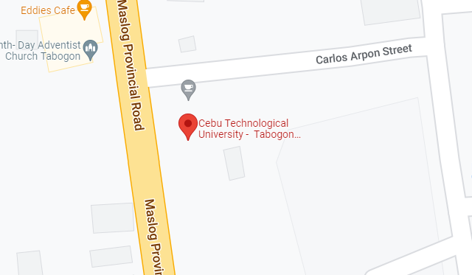

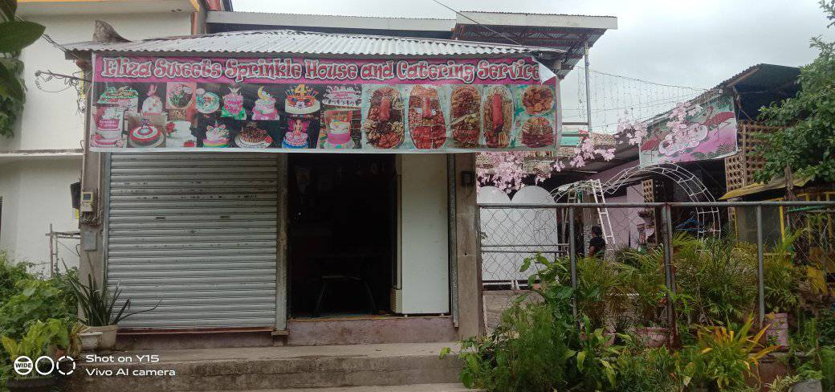

**ELIZA SWEETS SPRINKLE HOUSE AND CATERING SERVICES**

**Descriptions and functions**

The Online Catering Reservation System is responsible for securing the records for those people who checked out menu and also to maintain each transaction smooth.

**The main services are:**

1. The system will record every checked-out menu by the customer.
2. The system will monitor the transactions of the members.
3. The admin can control all the functionalities within the system.

**Location or Address**

Barangay Piyo, Tabogon, Cebu – Online Catering Reservation System



**Current System Used (as-is-system)**

1. Manual keeping of files of the transactions happened within the catering establishment.

**Problems Encountered**

1. Inaccurate records
2. Unreadable handwritten
3. Not accessible for people who are far in the catering services location

**Proposed Improvements (to-be-system)**

The staff should become computer illiterate and educated in the ways of the new world, where technology controls the majority of business interactions.

**Business Process**

The researchers proposed and suggested the **Eliza Sweets Sprinkle House and Catering Services** should now use the proposed system, Online Ordering Catering Reservation System in order for them to have an accurate record of all the transactions as well as the catering staff management.

**Figure 9. Usefulness in Developing SCA**

1. **Clarity Requirements –** Personal information are required to be registered to the system.
2. **Familiarity with the Technology –** The user must be computer literate enough to be able to use the system.
3. **System Complexity -** The user can use the system as long as they have an account and also should have a laptop or computer, a browser and a stable internet.
4. **System Reliability –** The Loan Management system is capable of storing and securing data registered to the database.

**STAFFING PLAN**

**Project Manager**

**Technical Head**

**Functional Head**

**Analyst 2**

**Analyst 1**

**Figure 10. Staffing Plan**

|  |  |  |
| --- | --- | --- |
| **Project Manager** | Monitors the project to ensure it reaches its goals and on budget. | **Joper G. Nuena** |
| **Functional Head** | Checks that the systems suggested meet the end users’ expectations and needs. | **Darwin M. Quimque/ Carlo D. Saladaga** |
| **Technical Head** | Track the systems compliance with end users’ specification and requirements. | **Jevy Callao/ Juramie Quinain** |
| **Analyst 1** | Designs the record keeping system based on the data flow. | **Dindo Tuling/ Ghruham Sabturani** |
| **Analyst 2** | Designs the UI of the system. | **Edrian Saladaga** |

**Table 2. Roles and Description of the system.**

**Working days: 70 Days**

|  |  |
| --- | --- |
| **STANDARD** | **ACTUAL** |
| **Planning Days** | **10 Days** |
| **Analysis Days** | **10 Days** |
| **Design Days** | **20 Days** |
| **Implementation Days** | **30 Days** |
| **Total Days** | **100 Days** |
|  |  |

**Table 3. Working Days (Project Time Frame)**

**Requirement Definition**

**Functional Requirements**

This system's functional specifications capture the anticipated behavior of the system. The system's required performance of these behaviors may be described as services, tasks, or functions. This system records and keeps track of all catering-related data.

**Non-functional Requirements**

In contrast with functional requirements that specify specific behavior or functions, non-functional requirements specify criteria that can be used to judge the operation of a system. The system should:

* Possess adequate processing power, memory, disk space, and network bandwidth.
* Perform well in terms of runtime and reaction time.
* To be available all the time when it is going to be used.
* To be maintainable.
* To be able to handle several users simultaneously.
* To be reliable such that the mean time between failures is close to zero.
* Have a secure
* ty mechanism to authenticate authorized users and keep out unauthorized users.
* To be robust enough to recover from failure or crash.
* Have both vertical and horizontal scalability to accommodate future expansions without losing data and applications that are already in it.

**Requirement Analysis Strategies**

**Problem Analysis**

Eliza Sweets Sprinkle House & Catering Services currently uses a paper-based online catering reservation system. This inevitably wastes time and results in seriously bad record-keeping. Long lines, redundant data, and lost customer information are examples of this, which highlights the necessity for an online catering reservation system that can improve security and record keeping.

**Work Breakdown Structure**

|  |  |  |  |  |  |
| --- | --- | --- | --- | --- | --- |
| **Task Name** | **Start Date** | **Finish Date** | **Duration (Days)** | **Persons Involved** | **Predecessor Task** |
| **Project Planning Phase** | 04/18/22 | 04/28/22 | 10 Days | A, B, C, D, E, F, G, H |  |
| 1.1 Project Identification and Initiation | 04/18/22 | 04/19/22 | 1 Day | A, B, C, D, E, F, G, H |  |
| 1.2 System Request | 04/19/22 | 04/20/22 | 1 Day | A, B, C, D, E, F, G, H | 1.1 |
| 1.3 Feasibility Study | 04/20/22 | 04/21/22 | 1 Day | A, B, C, D, E, F, G, H | 1.2 |
| 1.3.1 Technical | 04/21/22 | 04/22/22 | 1 Day | A, B, C, D, E, F, G, H | 1.3 |
| 1.3.2 Economic | 04/22/22 | 04/23/22 | 1 Day | A, B, C, D, E, F, G, H | 1.3.1 |
| 1.3.3 Organizational | 04/23/22 | 04/24/22 | 1 Day | A, B, C, D, E, F, G, H | 1.3.2 |
| 1.4 Development Methodology | 04/24/22 | 04/25/22 | 1 Day | A, B, C, D, E, F, G, H | 1.3.3 |
| 1.5 Project Time Frame | 04/25/22 | 04/26/22 | 1 Day | A, B, C, D, E, F, G, H | 1.4 |
| 1.6 Staffing Plan | 04/26/22 | 04/27/22 | 1 Day | A, B, C, D, E, F, G, H | 1.5 |
| 1.7 Work Plan | 04/27/22 | 04/28/22 | 1 Day | A, B, C, D, E, F, G, H | 1.6 |
| **Analysis phase** | 04/28/22 | 05/08/22 | 10 Days | A, B, C, D, E, F, G, H | 1.7 |
| 2.1 Functional and Non-functional requirements | 04/28/22 | 04/29/22 | 2 Days | A, B, C, D, E, F, G, H | 2 |
| 2.1.1 Functional requirements | 04/29/22 | 05/01/22 | 2 Days | A, B, C, D, E, F, G, H | 2.1 |
| 2.1.2 Non-functional requirements | 05/01/22 | 05/03/22 | 2 Days | A, B, C, D, E, F, G, H | 2.1.1 |
| 2.2 Requirements Elicitation Techniques | 05/03/22 | 05/05/22 | 2 Days | A, B, C, D, E, F, G, H | 2.1.2 |
| 2.3 Requirement Analysis Strategies | 05/05/22 | 05/07/22 | 2 Days | A, B, C, D, E, F, G, H | 2.2 |
| **Design Phase** | 05/07/22 | 05/27/22 | 20 Days | A, B, C, D, E, F, G, H | 2.3 |
| 3.1 Design Strategy | 05/07/22 | 05/11/22 | 4 Days | A, B, C, D, E, F, G, H | 3 |
| 3.2 Design the architecture of the system | 05/11/22 | 05/15/22 | 4 Days | A, B, C, D, E, F, G, H | 3.1 |
| 3.3 Design hardware and software selections | 05/15/22 | 05/19/22 | 4 Days | A, B, C, D, E, F, G, H | 3.2 |
| 3.4 Design Database and file specification | 05/19/22 | 05/23/22 | 4 Days | A, B, C, D, E, F, G, H | 3.3 |
| 3.5 Design system navigation inputs and outputs | 05/23/22 | 05/27/22 | 4 Days | A, B, C, D, E, F, G, H | 3.4 |
| **Implementation phase** | 05/27/22 | 06/28/22 | 30 Days | A, B, C, D, E, F, G, H | 3.5 |
| 4.1 Developing the system | 05/27/22 | 05/29/22 | 2 Days | A, B, C, D, E, F, G, H | 4 |
| 4.1.1 Assigning programming tasks | 05/29/22 | 05/30/22 | 1 Day | A, B, C, D, E, F, G, H | 4.1 |
| 4.1.2 Coordinating activities | 05/30/22 | 06/01/22 | 1 Day | A, B, C, D, E, F, G, H | 4.1.1 |
| 4.1.3 Managing schedule | 06/01/22 | 06/03/22 | 2 Days | A, B, C, D, E, F, G, H | 4.1.2 |
| 4.2 Testing the system | 06/03/22 | 06/04/22 | 1 Day | A, B, C, D, E, F, G, H | 4.1.3 |
| 4.2.1 Test Planning | 06/04/22 | 06/06/22 | 2 Days | A, B, C, D, E, F, G, H | 4.2 |
| 4.2.2 Unit Test | 06/06/22 | 06/08/22 | 2 Days | A, B, C, D, E, F, G, H | 4.2.1 |
| 4.2.3 Integration Tests | 06/08/22 | 06/10/22 | 2 Days | A, B, C, D, E, F, G, H | 4.2.2 |
| 4.2.4 System Testing | 06/10/22 | 06/12/22 | 2 Days | A, B, C, D, E, F, G, H | 4.2.3 |
| 4.2.5 Acceptance Testing | 06/12/22 | 06/14/22 | 2 Days | A, B, C, D, E, F, G, H | 4.2.4 |
| 4.3 Documentation | 06/14/22 | 06/16/22 | 2 Days | A, B, C, D, E, F, G, H | 4.2.5 |
| 4.3.1 System Documentation | 06/16/22 | 06/18/22 | 2 Days | A, B, C, D, E, F, G, H | 4.3 |
| 4.3.2 User Documentation | 06/18/22 | 06/20/22 | 2 Days | A, B, C, D, E, F, G, H | 4.3.1 |
| 4.4 Operating Procedures | 06/20/22 | 06/22/22 | 2 Days | A, B, C, D, E, F, G, H | 4.3.2 |
| 4.4.1 Reference | 06/22/22 | 06/24/22 | 2 Days | A, B, C, D, E, F, G, H | 4.4 |
| 4.4.2 Procedures Manuals | 06/24/22 | 06/26/22 | 2 Days | A, B, C, D, E, F, G, H | 4.4.1 |
| 4.4.3 Tutorials | 06/26/22 | 06/28/22 | 2 Days | A, B, C, D, E, F, G, H | 4.4.2 |

**Chapter 5**

**USER INTERFACE DESIGN**

**HTML PROTOTYPE**

**LOG-IN PAGE**

To access the system, users must log in using their personal information, such as their email address and password, on this page.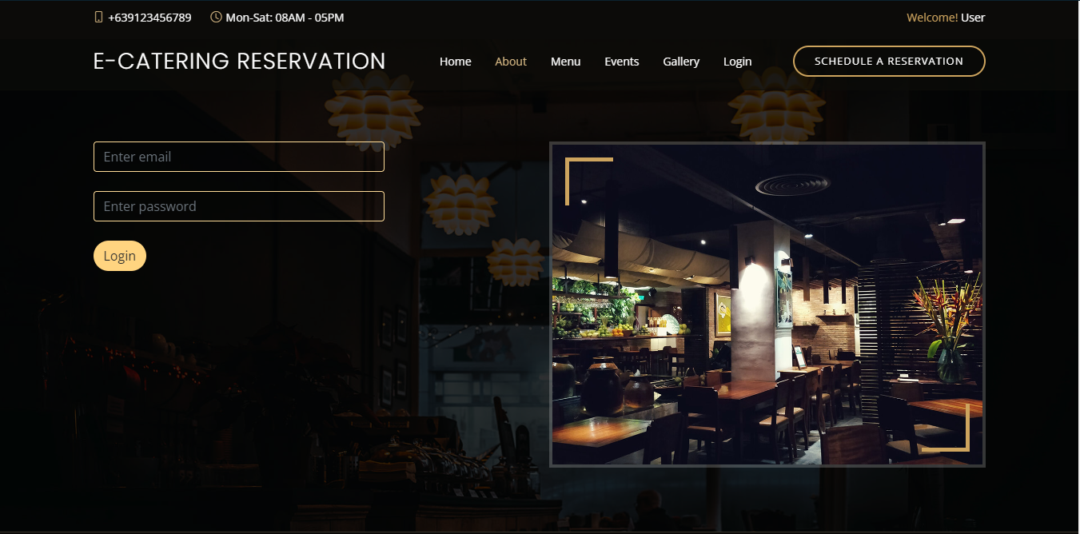

**DASHBOARD**

The dashboard displays the number of records of menu, categories, sub-category, reservation list, administrators and users list.

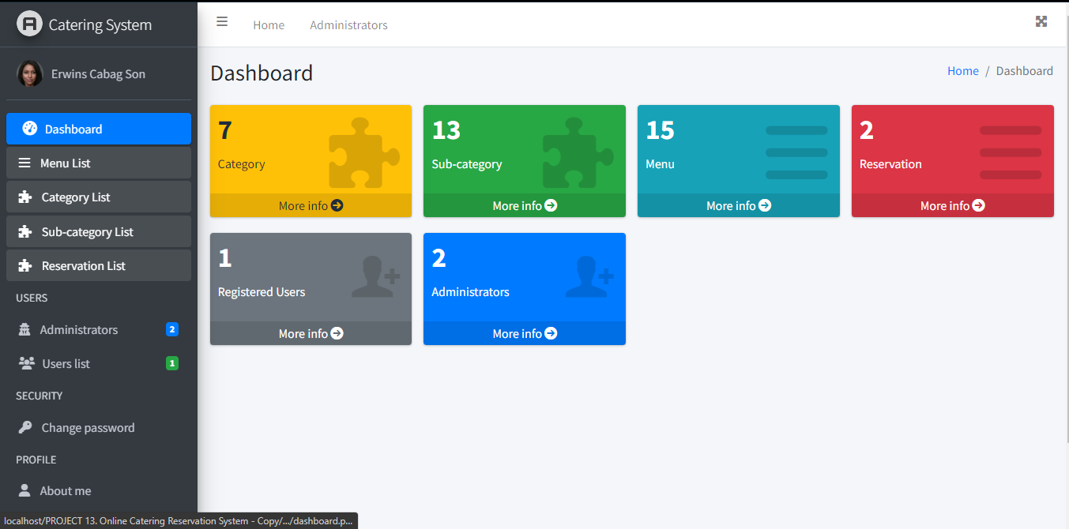

**LIST OF MENUS**

This is where the Administrator will see the list of menus who ordered for selected menu.

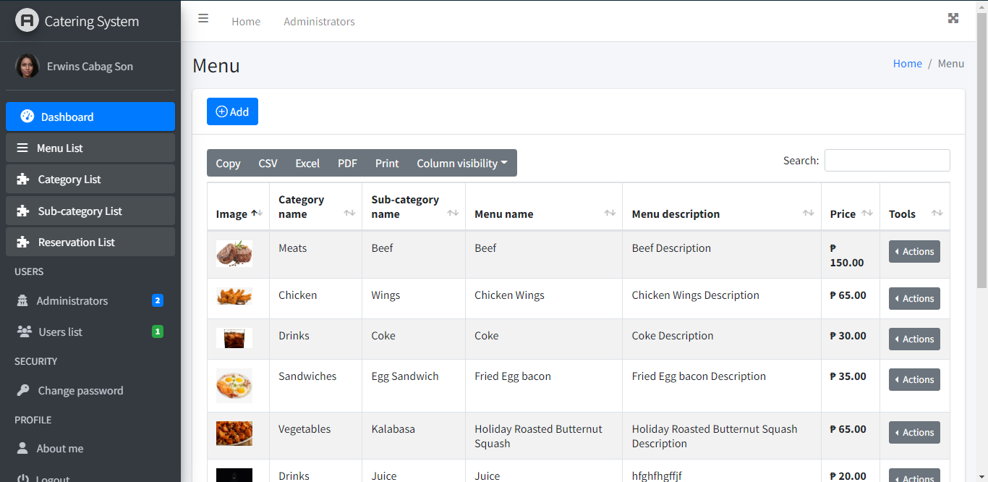

**LIST OF CATEGORIES**

This is where the Administrator will see the list of categories for menu.

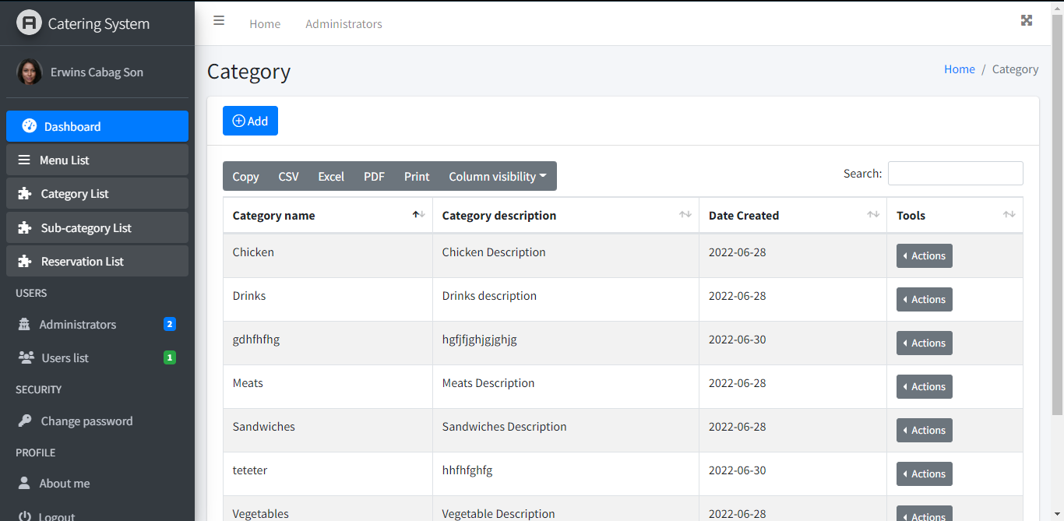

**LIST OF SUB-CATEGORIES**

This is where the Administrator will see the list of sub-categories for menu.

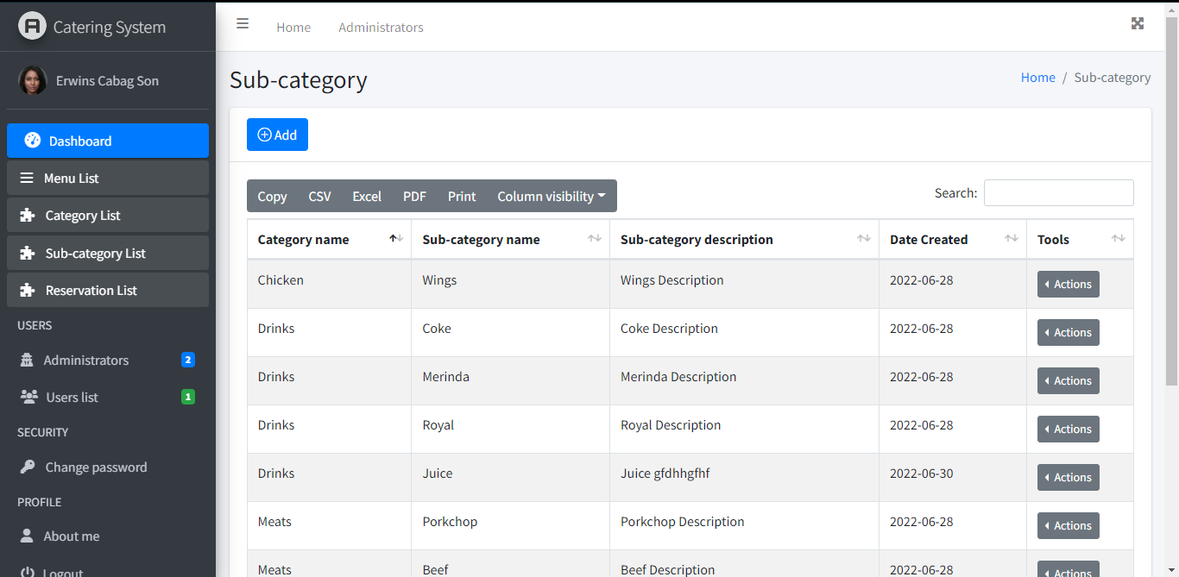

**LIST OF RESERVATION**

This page displays the records of the reserver where Administrators can approve or deny reservation.

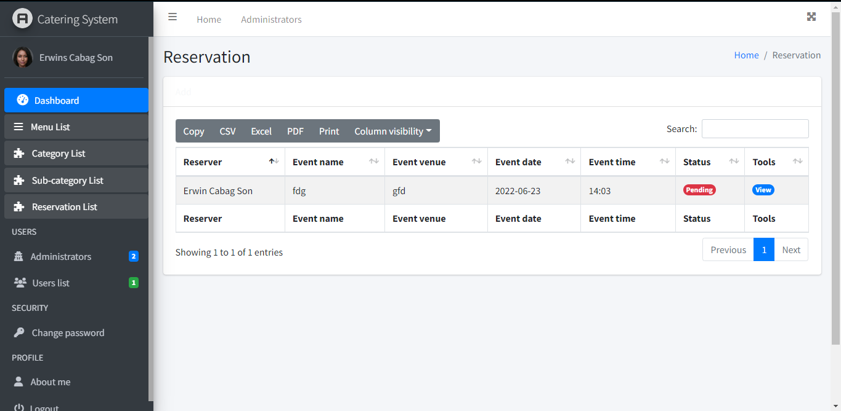

**REGISTERED USERS**

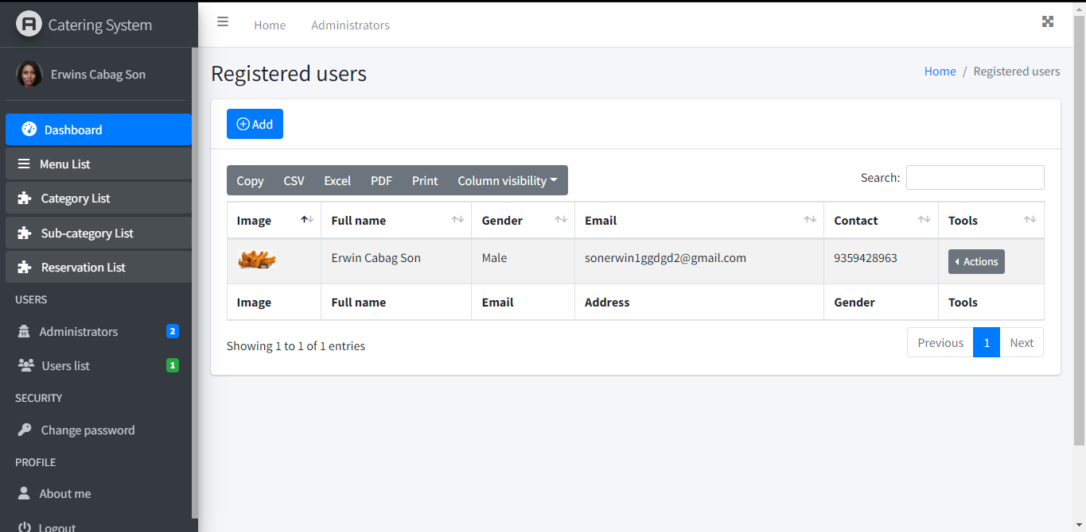 Registered users’ page shows the records of the member who registered into the system.

**CHANGE PASSWORD PAGE**

Admin can change his/her password through accessing the change password page.

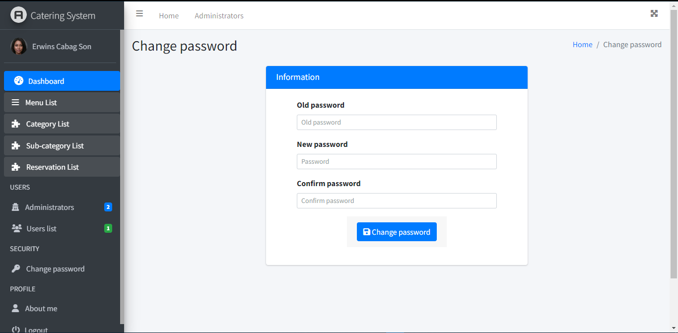

**ADMIN LOGOUT**

This system also allows users to logout their account after accessing the system.

